Students

1. Create Student

* **Method**: POST
* **Endpoint**: /student
* **Request Body**:

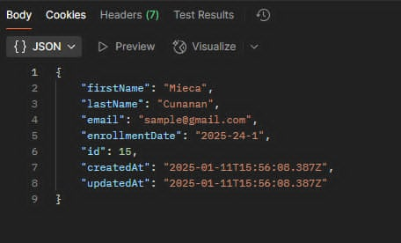

**Response**:

* **Status**: 201 Created
* **Body**:

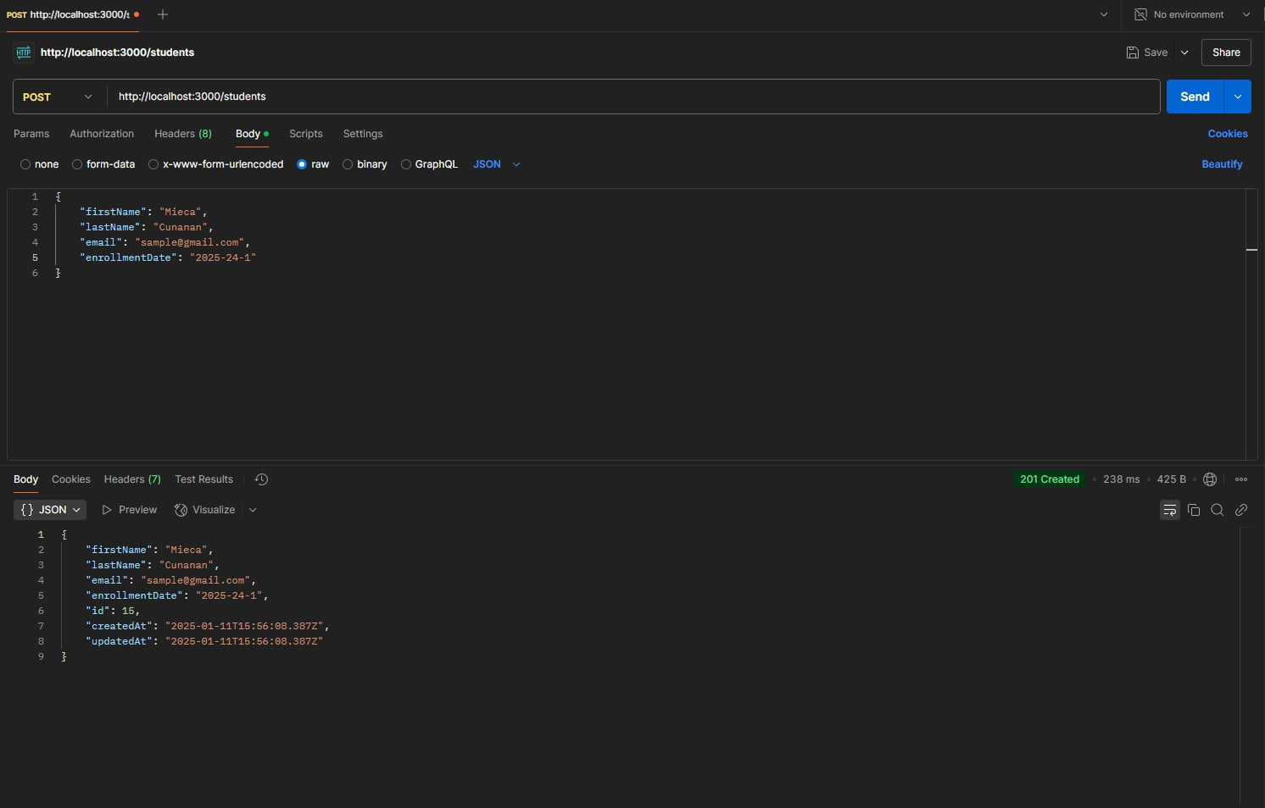

**Get All Students**

* **Method:** GET
* **Endpoint: /**students
* **Status**: 200 OK
* **Body:**

